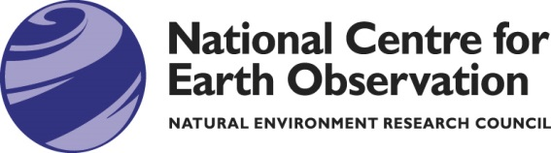
Earth Observation Conference
- Science and Technologies
27 – 30 June 2017

CALL FOR ABSTRACTS

We invite abstract submissions – on science and/or technology – for talks, posters, demonstrations and exhibitions, in the following categories:

- The Energy and Water Cycle
- Environmental Hazards
- Data Assimilation and Models
- Climate and Long-term Datasets
- Land-Atmosphere Interactions
- Ocean and Ice
- The Carbon Cycle
- Working with Industry and Governments
- Facilities, Technologies and Tools
- Other

Details to be submitted:
Name
Email address
Telephone number
Institute or Company
Abstract title
Abstract detail | (100 words maximum)
Category, 1-10 from the list above (please note that you can nominate more than one)
Are you submitting a talk, poster, exhibit or demonstration?

Complete the above details and return by email to: jan.fillingham@nceo.ac.uk by 12 May 2017

